GENERAL INFORMATION
The University of Houston System is required to comply with state contract reporting requirements. To help ensure compliance, the UHS Contracts Page will be used as a single point of data entry for all contract information that the University is required to report to the Legislative Budget Board (LBB) either by statute or the General Appropriations Act (GAA). Purchasing staff will use the data collected from this page to report contracts to the LBB.

- All CN730 & CN783 requisitions require that contract information be entered via the UHS Contracts Page. See page 3 for instructions on how to report expense contracts. See Procurement Thresholds and UHS Purchasing Guidelines for contracts that require a CN730/CN783 requisition.
  - Procurement Thresholds: http://www.uh.edu/administration-finance/purchasing/Purchasing%20Training/procurement-thresholds/
  - UHS Purchasing Guidelines: http://www.uh.edu/office-of-finance/purchasing/faculty-staff-resources/

- All revenue generating contracts amounts greater than $50,000 will need to be reported via the UHS Contracts Page. See page 6 for instructions on how to report revenue contracts.
Note: A copy of the fully executed signed agreement is no longer required to be uploaded to CN730/CN783 requisitions. A copy of the fully executed signed agreement must be uploaded to the UHS contracts page, along with the Contract Coversheet, Recommendation for Award, Sole Source Justification form (if applicable), and any bids/quotes obtained by the originating department.
The University is required to report contracts to the LBB as follows:

TYPE OF CONTRACT | VALUE THRESHOLD | REPORTING TIMEFRAME | LOCATION
All | > $50,000 | Within 30 days of award or amendment | GAA, Article IX §7.04  Government Code §322.020
Non-Competitive/Sole Source | > $1,000,000 | Within 15 days of award | GAA, Article IX §7.11
Emergency | > $1,000,000 | Within 5 days of award | GAA, Article IX §7.11
All | > $10,000,000 | Within 15 days of award | GAA, Article IX §7.11

CONTRACT AMENDMENTS
For reporting purposes, contract amendments will be treated as separate contract entries. Departments will need to create a new contract in the system to record the amendment and link it to the requisition.

See example below:

Original Contract (executed 8/22/2019)
Contract ID: K-19-12345
Total Amount: $100,000
Term: 9/1/2019 – 8/31/2022

Amendment 1 (executed 7/15/2022)
Contract ID: K-19-12345-1
Total Amount (original + amendment): $175,000
Term (original + amendment): 9/1/2019 – 8/31/2024

FY20 - Department creates requisition #1 and enters contract K-19-12345
FY21 - Department creates requisition #2 and links it to contract K-19-12345
FY22 - Department creates requisition #3 and links it to contract K-19-12345
FY23 - Department creates requisition #4 and enters amendment K-19-12345-1
FY24 - Department creates requisition #5 and links it to amendment K-19-12345-1

INSTRUCTIONS FOR EXPENSE CONTRACTS (see page 6 for instructions for revenue contracts)
Expense contracts are submitted via requisition. Every CN730 and CN783 requisition should have a contract linked to it.
Step 1: Create requisition by following the “How to create a requisition” training located at http://www.uh.edu/office-of-finance/purchasing/Purchasing%20Training/
Note that the “Contract” page is only available for CN730 & CN783 requisitions.
Step 2: Click on the “Contract” tab. Expense contracts can be created and/or added from this page.
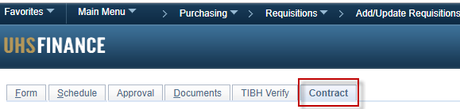
- Add an existing contract to the requisition by going to the “Add Existing Contract” section below. Note that you can only add an existing contract if someone already created that contract.
- Create a new contract by going to Step 3.
Add Existing Contract
- Click the search icon. The Look Up page is displayed.
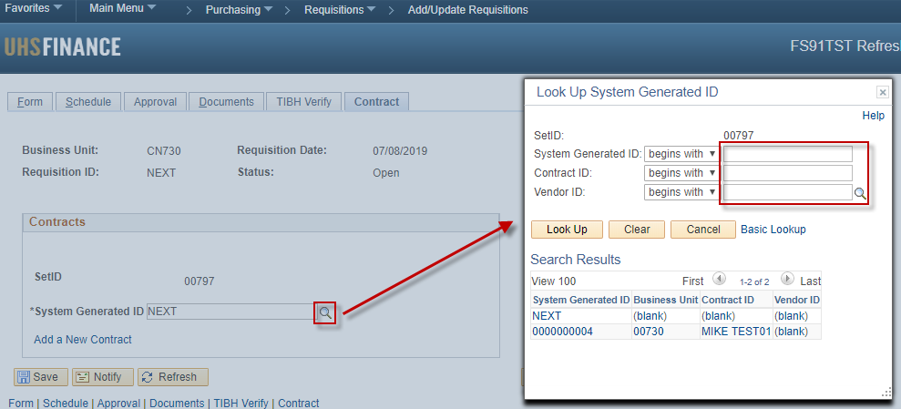
- You can search for contracts by:
System Generated ID | This is a 6-digit unique number that is automatically generated by the system once a contract is saved.
Contract ID | K Number assigned by OCA or department assigned number if no K number available.
Vendor ID | Unique number assigned to vendors that receive non-payroll payments from UH System.
- Once contract is found, select to add and click save.
- You can view the selected contract by clicking on the “View Contract” link.
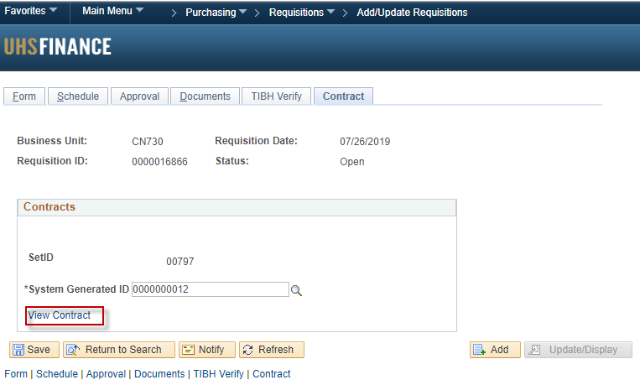
Step 3: Click the “Add New Contract” link. Do not enter anything on the “System Generated ID” field.
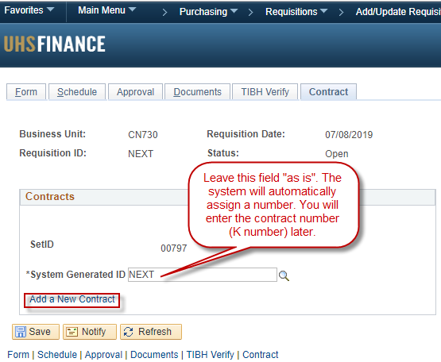
Step 4: Fill out all the applicable fields. Use the following definitions to determine what information needs to be entered.
Contract ID | Use the Contract ID (K Number) assigned by the Office of Contract Administration (OCA). Use department-assigned contract number only if there is not a K number available. The K number or department-assigned number must be stamped on all contract documents in order for Purchasing to verify contract ID entered in the UHS contracts page is correct.
Amended | Only select this box if contract has been amended.
Subject | The subject provides a description of the contract’s general purpose. Example: Disaster Restoration & Emergency Recovery Services.
Competitively Procured | This field is used to differentiate between competitively and non-competitively procured contracts.
Revenue Generating | Do not check this box when entering expense contracts
Agency Approval Date | The Agency Approval Date specifies the date on which final approval was given to proceed with contracting for the purchase or sale of goods and/or services. The Agency Approval Date cannot be later than the Solicitation Post Date or the Award Date.  Please use one of the options below:  - Formal bid - date formal solicitation was posted to the ESBD.  - Informal bid - dates bids were requested from vendors.  - Sole source or emergency - date Purchasing signed the sole source justification form or approved the emergency purchase.
Award Date | The Award Date is the date the University executed (signed) the contract.
Expiration Date | The Expiration Date is the date when the contract will end pursuant to its terms and conditions.
Vendor ID | Unique number assigned to vendors that receive non-payroll payments from UH System.
Address | Use vendor address listed on contract. If address is not found use the same address as PO.
Current Value | The Current Contract Value includes the value of the contract, any amendments, and any exercised extensions or renewals.
Maximum Value | The Maximum Contract Value field should include the value of the contract, amendments, and all potential extensions or renewals that have not been exercised. The total amount both currently and potentially obligated.
Solicitation Posting Date | Enter date solicitation was posted for public bidding OR leave blank if not applicable. This is normally found on the first page of the solicitation.
Number of Bids Received | The # of Bids Received is used to indicate the number of bids that the University received in response to the formal/informal solicitation. Enter 1 if state contract, cooperative contract, or sole source purchase.
Solicitation Number | Enter solicitation number or NA if not applicable.
Step 5: Attach files.
Step 6: Save & Submit.

INSTRUCTIONS FOR REVENUE CONTRACTS (see page 3 for instructions for expense contracts)

Revenue contracts do not require a requisition, therefore, they should not be linked to requisitions. Departments are required to submit revenue contracts for reporting via the UHS Contracts Page which can be accessed following the below steps.

Step 1: Go to the UHS Contract Entry page by clicking Main Menu → Purchasing → UHS Contracts → UHS Contract Entry.

Step 2: Click add on the UHS Contracts Entry page. Do not enter anything on the “System Generated ID” field.

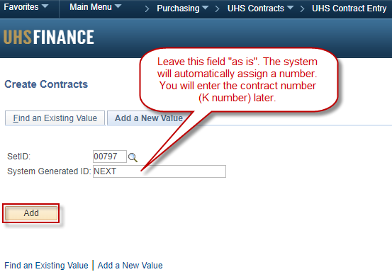

Step 3: Fill out all the applicable fields. Use the following definitions to determine what information needs to be entered.
Contract ID | Use the Contract ID (K Number) assigned by the Office of Contract Administration (OCA). Use department-assigned contract number only if there is not a K number available. The K number or department-assigned number must be stamped on all contract documents in order for approver to verify contract ID entered in the UHS contracts page is correct.
Amended | Only select this box if contract has been amended.
Subject | The subject provides a description of the contract’s general purpose. Example: Disaster Restoration & Emergency Recovery Services.
Competitively Procured | This field is used to differentiate between competitively and non-competitively procured contracts.
Revenue Generating | Check this box. When asked whether the vendor is in the system enter:  - Yes – look up vendor ID and Address  - No – Manually enter vendor name and address.
Agency Approval Date | The Agency Approval Date specifies the date on which final approval was given to proceed with contracting for revenue generating transactions. The Agency Approval Date cannot be later than the Solicitation Post Date or the Award Date.  Please use one of the options below:  - Formal bid - date formal solicitation was posted to the ESBD.  - Informal bid - dates bids were requested from vendors.  - Sole source or emergency - date Purchasing signed the sole source justification form or approved the emergency purchase.  - If none of the above, use the oldest date found on the contract internal forms (i.e. coversheet, memo, etc.) which documented the approval to move forward with contracting for revenue generating transactions.
Award Date | The Award Date is the date the University executed (signed) the contract.
Expiration Date | The Expiration Date is the date when the contract will end pursuant to its terms and conditions.
Vendor ID | Unique number assigned to vendors that receive non-payroll payments from UH System.
Address | Use vendor address listed on contract. Manually enter address if vendor is not found on the system.
Current Value | The Current Contract Value includes the value of the contract, any amendments, and any exercised extensions or renewals.
Maximum Value | The Maximum Contract Value field should include the value of the contract, amendments, and all potential extensions or renewals that have not been exercised. The total amount both currently and potentially obligated.
Solicitation Posting Date | Enter date solicitation was posted for public bidding OR leave blank if not applicable. This is normally found on the first page of the solicitation.
Number of Bids Received | The # of Bids Received is used to indicate the number of bids that the University received in response to the formal/informal solicitation. Enter 1 if state contract, cooperative contract, sole source purchase, or revenue contract.
Solicitation Number | Enter solicitation number or NA if not applicable.
Step 5: Attach files.
Step 6: Save & Submit.

CONTACT US
If you have any questions regarding the UHS Contracts Page or LBB Contracts Reporting in general, please contact:

- Pascual Espinoza, 713-743-2084, pespinoz@central.uh.edu
- Tiffany Brandyberg, 713-743-5714, tbrandyberg@uh.edu

